ECO394D Probability and Statistics Homework 4

Sibo Ding

Summer 2023

## Problem 1

### Part A

Question: Does one of “Living with Ed” and “My Name is Earl” have a higher mean Q1_Happy than the other?  
Approach: 2-sample two-sided t-test  
Results:

##   
## Welch Two Sample t-test  
##   
## data: lwe and mni  
## t = 1.1676, df = 162.57, p-value = 0.2447  
## alternative hypothesis: true difference in means is not equal to 0  
## 95 percent confidence interval:  
## -0.1030341 0.4011371  
## sample estimates:  
## mean of x mean of y   
## 3.926829 3.777778

Conclusion: p-value is greater than 0.05 (or 95% confidence interval includes 0). We cannot reject $H_{0}$ so no one show has a higher mean Q1_Happy at 5% significance.

### Part B

Question: Does one of “The Biggest Loser” and “The Apprentice: Los Angeles” have a higher mean Q1_Annoyed than the other?  
Approach: 2-sample two-sided t-test  
Results:

##   
## Welch Two Sample t-test  
##   
## data: tbl and tal  
## t = -2.1032, df = 300.66, p-value = 0.03628  
## alternative hypothesis: true difference in means is not equal to 0  
## 95 percent confidence interval:  
## -0.52455614 -0.01743792  
## sample estimates:  
## mean of x mean of y   
## 2.036232 2.307229

Conclusion: p-value is smaller than 0.05 (or 95% confidence interval does not include 0). We reject $H_{0}$ so one show has a higher mean Q1_Annoyed at 5% significance.

### Part C

Question: Use a filtered data set to infer the proportion of 4 or grater Q2_Confusing of “Dancing with the Stars” with its 95% confidence interval.  
Approach 1: 1-sample proportions test  
Results:

##   
## 1-sample proportions test with continuity correction  
##   
## data: sum(dwt$Q2_Confusing >= 4) out of length(dwt$Q2_Confusing >= 4), null probability 0.5  
## X-squared = 127.65, df = 1, p-value < 2.2e-16  
## alternative hypothesis: true p is not equal to 0.5  
## 95 percent confidence interval:  
## 0.04453431 0.12893254  
## sample estimates:  
## p   
## 0.07734807

Approach 2: Normal approximation for binomial distribution (based on C.L.T.)  
Results:  
Actual proportion $p=$

## [1] 0.07734807

Sample size $n=$

## [1] 181

$\hat{p}∼N\left(p,\frac{p\left(1−p\right)}{n}\right)=N\left(0.0773,{0.0199}^{2}\right)$ $E\left(\hat{p}\right)=p=0.0773$ $CI{\left(p\right)}_{0.95}=p±z\sqrt{\frac{p\left(1−p\right)}{n}}=0.0773±1.96×0.0199$

## Lower limit: 0.03842989

## Upper limit: 0.1162662

Approach 3: Use bootstrap and Monte Carlo simulation to generate many samples and estimate C.I..

## Problem 2

Question: Whether the revenue ratios are the same in the treatment and control groups?  
Approach: 2-sample two-sided t-test  
Results:

##   
## Welch Two Sample t-test  
##   
## data: control and treatment  
## t = 2.6367, df = 110.2, p-value = 0.00958  
## alternative hypothesis: true difference in means is not equal to 0  
## 95 percent confidence interval:  
## 0.01298714 0.09157576  
## sample estimates:  
## mean of x mean of y   
## 0.9488775 0.8965961

Conclusion: p-value is smaller than 0.05 (or 95% confidence interval does not include 0). We reject $H_{0}$ so the revenue ratios in the treatment and control groups are different at 5% significance.

## Problem 3

$H_{0}$: The proportion of flagged trades from Iron Bank is 2.4%.  
Test statistic: $rate=\frac{70}{2021}$  
When plotting simulation results, histogram rather than p.d.f. makes more sense:

## Registered S3 method overwritten by 'mosaic':  
## method from   
## fortify.SpatialPolygonsDataFrame ggplot2

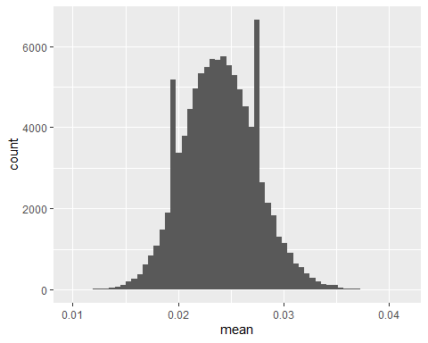

p-value for observing $rate>\frac{70}{2021}=$

## [1] 0.00129

Conclusion: $H_{0}$ is not plausible in light of the data because $p<0.01$ is pretty small, which is very rare to happen.

## Problem 4

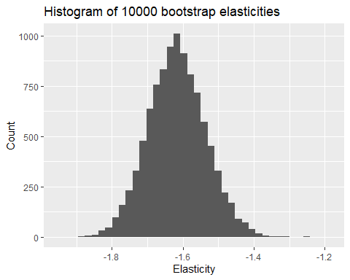

## Confidence Interval from Bootstrap Distribution (10000 replicates)

## 2.5% 97.5%  
## percentile -1.77 -1.45

## Problem 5

### Part A

1. $∵X_{1},…,X_{N}∼i.i.d.Bernoulli\left(p\right)$ $E\left(\hat{p}\right)=E\left({\overset{‾}{X}}_{N}\right)=E\left(\frac{X_{1}+⋯+X_{N}}{N}\right)$ $=\frac{1}{N}\left(E\left(X_{1}\right)+⋯+E\left(X_{N}\right)\right)$ $=\frac{1}{N}NE\left(X\right)$ $=p$ Similarly, $E\left(\hat{q}\right)=q$, thus $E\left(\hat{p}−\hat{q}\right)=E\left(\hat{p}\right)−E\left(\hat{q}\right)=p−q$
2. Since $X_{1},…,X_{N}∼i.i.d.Bernoulli\left(p\right)$ having the same finite mean and variance, as $N→∞$, based on C.L.T., $se\left({\overset{‾}{X}}_{N}\right)=\frac{sd\left(X\right)}{\sqrt{N}}=\sqrt{\frac{p\left(1−p\right)}{N}}$
3. $∵X_{1},…,X_{N}∼i.i.d.Bernoulli\left(p\right)$, $Y_{1},…,Y_{M}∼i.i.d.Bernoulli\left(q\right)$  
   Based on C.L.T., $Var\left(\hat{p}\right)=\frac{Var\left(X\right)}{N}=\frac{p\left(1−p\right)}{N}$, $Var\left(\hat{q}\right)=\frac{Var\left(Y\right)}{M}=\frac{q\left(1−q\right)}{M}$ $∴Var\left(\hat{p}−\hat{q}\right)=Var\left(\hat{p}\right)+Var\left(\hat{q}\right)=\frac{p\left(1−p\right)}{N}+\frac{q\left(1−q\right)}{M}$ $se\left(\hat{p}−\hat{q}\right)=\sqrt{\frac{p\left(1−p\right)}{N}+\frac{q\left(1−q\right)}{M}}$

### Part B

Similar to Part A, $E\left({\overset{‾}{X}}_{N}−{\overset{‾}{Y}}_{M}\right)=E\left({\overset{‾}{X}}_{N}\right)−E\left({\overset{‾}{Y}}_{M}\right)=μ_{X}−μ_{Y}$ $Var\left({\overset{‾}{X}}_{N}−{\overset{‾}{Y}}_{M}\right)=Var\left({\overset{‾}{X}}_{N}\right)+Var\left({\overset{‾}{Y}}_{M}\right)=\frac{σ_{X}^{2}}{N}+\frac{σ_{Y}^{2}}{M}$ $se\left({\overset{‾}{X}}_{N}−{\overset{‾}{Y}}_{M}\right)=\sqrt{\frac{σ_{X}^{2}}{N}+\frac{σ_{Y}^{2}}{M}}$